

AUGUST 2019 EXAMINATION

School of InfoComm Technology

(Diploma in Information Security & Forensics)

(Diploma in Information Technology)

## Level 2 Time Allowed: 2 Hours

# **NETWORKING INFRASTRUCTURE**

# **(011789)**

INSTRUCTIONS TO CANDIDATES:

**1. Check carefully to ensure you are sitting for the correct paper.**

2. There are FIVE questions. Answer ALL questions.

3. All questions carry equal marks.

4. Begin each question on a separate page.

5. This paper consists of 9 pages including this cover page. Check carefully to make sure your set is complete.

There are FIVE questions. Answer **ALL** questions.

**QUESTION 1** (20 marks)

You have recently started work as a Network Administrator in TBC Company. Figure 1 shows the inter-switch connections of TBC’s network.

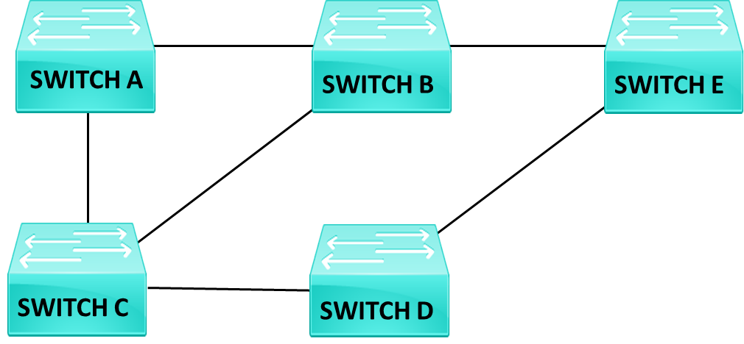

Figure 1: Inter-Switch Connections of TBC Company

(a) Ethernet switches typically use Store-and-Forward switching mode. Briefly describe how this switching mode operates and explain why it is preferred over Cut-Through switching mode.

(4 marks)

(b) Based on the spanning tree protocol, identify and explain how the following are determined for the switching network in Figure 1.

1. Root bridge
2. Root ports
3. Designated ports
4. Blocked ports

Redraw Figure 1 in your answer booklet and indicate the root bridge, root ports, designated ports and blocked ports.

Assume that all the switches are set with the same default priority value; and Switch A has the lowest MAC address while Switch E has the highest MAC address.

(11 marks)

(c) Draw the final inter-switch active connections after spanning tree protocol has converged.

(2 marks)

(d) Briefly explain why it is not desirable to rely on MAC addresses to select the root bridge. Suggest how you would fix the selection.

(3 marks)

**QUESTION 2** (20 marks)

Figure 2 shows a network of five routers. All their interfaces are configured with subnet mask of 255.255.255.0. The IP addresses of the routers’ interfaces are as depicted. A dynamic routing protocol will be used on Router B, C, D and E.

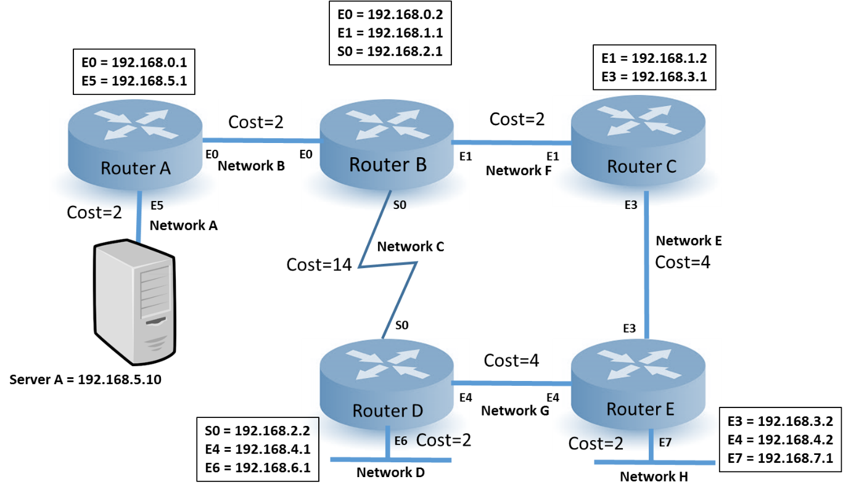

Figure 2: Network of five routers

(a) Router A is in a stub network. Explain why static routing is preferred for Router A.

Since router A is only in a single path network, it can only send to router B, and no need other route information. Therefore, a static default route on router A is the most efficient way.

(2 marks)

(b) Show the commands to configure static routes in Router A and Router B to enable all networks to access Server A.

Router A: ip route 0.0.0.0 0.0.0.0 192.168.0.2

Router B: ip route 192.165.5.0 255.255.255.0 192.168.0.1

(4 marks)

(c) Assuming that Routing Information Protocol (RIP) was used in this network, fill in the routing table of Router B when the network has converged after the exchange of routing information.

(Redraw and complete Table 2(c) in the Answer Booklet)

(6 marks)

|  |  |  |
| --- | --- | --- |
| **Network** | **Next Hop IP Address** | **Metric (Hop Count)** |
| **D** | **192.168.2.2** | **1** |
| **G** | **192.168.2.2** | **1** |
| **H** | **192.168.1.2/192.168.2.2** | **2** |

Table 2(c): Routing Table of Router B (RIP)

**QUESTION 2** (cont.)

(d) Assuming that Open Shortest Path First (OSPF) was used in this network, fill in the routing table of Router B.

(Redraw and complete Table 2(d) in the Answer Booklet)

(4 marks)

|  |  |  |
| --- | --- | --- |
| **Network** | **Next Hop IP Address** | **Metric (Cost)** |
| **D** | **192.168.1.2** | **12** |
| **G** | **192.168.1.2** | **10** |
| **H** | **192.168.1.2** | **8** |

Table 2(d): Routing Table of Router B (OSPF)

(e) Based on the answers provided in the routing tables for RIP in part (c) and OSPF in part (d), provide TWO reasons to justify which routing protocol is recommended for this network.

* Network D and G users will use the show WAN link (highest cost) to communicate with the server if RIP is used; OSPF takes the speed and not the hop count
* Not as bandwidth intensive as RIP which is important as one of the link is a WAN link which is slow and expensive.

(4 marks)

**QUESTION 3** (20 marks)

1. Bravo Company is using Class C IP addresses with a Network ID of 200.2.2.0. As the Network Administrator, you are tasked to provide an IP addressing scheme to allow up to 8 subnets. The number of hosts in each subnet will not exceed 12. Assume that subnet zero and subnet all ones are NOT allowed.

(i) Determine the minimum number of subnet bits and the maximum number of hosts per subnet to meet the company’s network requirements. Show your working clearly.

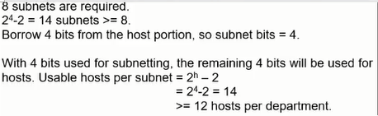

(4 marks)

(ii) Determine the first three usable subnets and their IP address ranges to complete the table below. Show your working clearly.

(Redraw and complete Table 3(a)(ii) in the answer booklet)

(6 marks)

|  |  |  |  |
| --- | --- | --- | --- |
|  | Network ID (200.2.2.0) | Subnet Bits | Host IP Range |
| 1st Usable Subnet | 200.2.2.16 | 0001 | 17-30 |
| 2nd Usable Subnet | 200.2.2.32 | 0010 | 33-46 |
| 3rd Usable Subnet | 200.2.2.48 | 0011 | 49-62 |

Table 3(a)(ii): Usable Subnets

**QUESTION 3** (cont.)

1. Two VLANs were configured by the Network Administrator on two layer 3 switches with VLAN trunking on port 7 (P7) of both switches. Switch 1 is located on Level 1 and Switch 2 on Level 2 respectively. All computers have been configured with the IP addresses as shown in Figure 3(b).

Figure 3(b): VLAN Configuration for Switch 1 and Switch 2

(i) After completing the first step of adding VLAN memberships to the switch ports, the Network Administrator tried to ping the File Server from PC2. Will he get a successful ping? Briefly explain your answer.  
No, the file server and PC2 is in different VLAN

(2 marks)

(ii) VLAN trunking configuration was set up on port 7 of both switches. Explain the purpose of the VLAN trunking and VLAN tagging.

VLAN trunking is the area used for inter-switch VLAN communication.

VLAN tagging is a tag that allow the switch to determine the source and destination VLAN ID for each frame.

(4 marks)

(iii) State the IP address of the default gateway when the Network Administrator types “ipconfig” at the command prompt of PC1.  
192.168.2.1

(2 marks)

(iv) Based on the current Vlan 3 configuration, PC3 is unable to access the Internet through Router1. Suggest and explain ONE solution to allow PC3 to have Internet access.  
Enable inter-VLAN routing, it allow PC3 in VLAN 3 to route to router 1 in VLAN 2

(2 marks)

**QUESTION 4** (20 marks)

Southwind company has a domain name of sw.com with one office in Singapore and one in Indonesia. Eastwind company has a domain name of ew.com with one office in China and one in Hong Kong. Due to their weak financial cashflow and strong international competition, a merger decision was made in order to strengthen their positions and to compete globally.

Both companies have decided to keep their domain names but will be administered under the Southwind network.

1. Propose, with a well-labelled diagram, a multiple-domain Active Directory (AD) structure for both networks. Your answer should clearly label the AD components: domain, tree and forest.  
   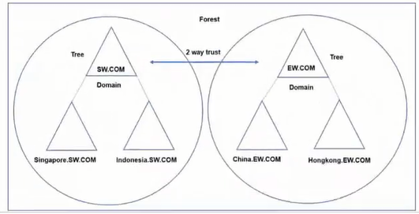

(6 marks)

(b) Briefly explain why Active Directory structure is required in Southwind and Eastwind network.  
Active directory provide simplified and efficient system administration for the organization. It provides a directory service infrastructure that helps to mage the resources throughout the network.

(2 marks)

(c) Explain the purpose of Distribution group and Security group in the Active Directory.  
Distribution group: For mailing

Security group: Assign permission or user right to group that need access to resources

(2 marks)

(d) During the process of the merger, one of the domain controllers failed. Some users were unable to log on to the network. Suggest ONE way to improve the reliability of the network.

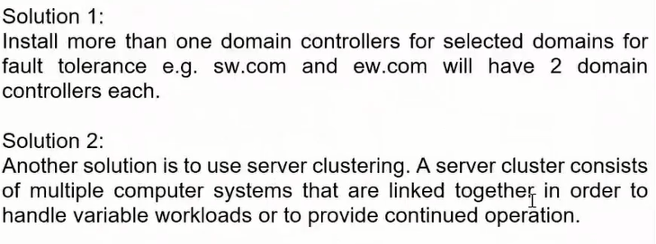

(2 marks)

(e) After the merger, there is a need for the Sales users of both companies to access the shared SALES folder located at the sw.com (Southwind domain). List down the group strategy to allow all the Sales users from both domains to access the shared SALES folder.  
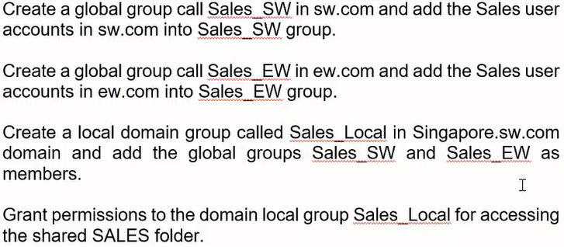

(8 marks)

**QUESTION 5** (20 marks)

(a) Figure 5(a) shows a portion of Southwind domain Active Directory (AD) structure. The Organizational Units (OU) in the AD are Marketing OU with one child OU and Tempstaff OU with two child OUs. The Group Policy Objects (GPOs) are linked to the OUs indicated by the arrow with dotted lines.

* GPOMarketingComp has a Computer Configuration setting to remove Run menu
* GPOTempstaffUser has a User Configuration setting to hide all icons from desktop and does not save settings on exit
* GPOTempstaffComp has a Computer Configuration setting to hide common program groups in the Start menu and does not save settings on exit

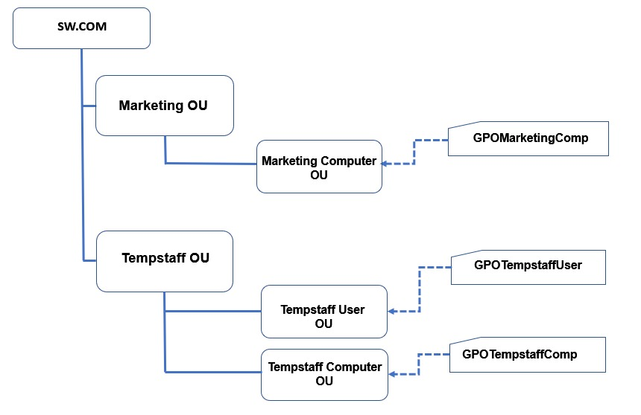

Figure 5(a): Portion of Southwind domain Active Directory (AD) Structure.

(i)Briefly describe what is a Group policy and list TWO areas of its deployment on software settings for multiple users and computers.

(4 marks)

(ii) A user whose user ID is in the Tempstaff User OU, logs into to a computer in Tempstaff Computer OU. Can the user access the common program groups in the Start menu? Briefly explain the reason.

(2 marks)

(iii) Some users in Tempstaff User OU logs into the computers in Marketing Computer OU. Will they see the desktop icons? Briefly explain the reason.

(2 marks)

(iv) Explain briefly why a newly created GPO may not take immediate effect. What is the command to enforce it immediately?

(2 marks)

**QUESTION 5** (cont.)

(b) ICT School is conducting an Artificial Intelligence (AI) course for 8 enrolled students. A shared folder, named AI, is created in a file server for students to submit their projects. When a student accesses the AI folder across the network, a list of subfolders is displayed as shown in Figure 5(b), where Student1 is the subfolder name for a student with user name Student1, etc.

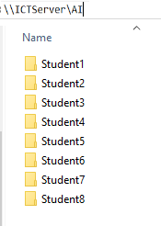

Figure 5(b): Listing of Subfolders in the \\ICTServer\AI Shared Folder

A student is only allowed to access his/her own folder and not others, for example, subfolder Student1 can only be accessed by a student with username Student1. User Student1 can deposit and edit files in his own folder.

The AI Lecturer can view, copy, deposit and delete the files in any of the student’s folders.

(i) You are the AI Lecturer setting up the Share and NTFS permissions for the shared subfolders. Complete the permission table below for the AI Lecturer and Student1 for the \\ICTServer\AI\Student1 subfolder.

(Redraw and complete the Table 5(b)(i) in the answer booklet)

(4 marks)

|  |  |  |
| --- | --- | --- |
| User | Share permission | NTFS Folder permission |
| AILecturer |  |  |
| Student1 |  |  |

Table 5(b)(i): Permission Table

(ii) Briefly explain how you would determine the effective permission when you combine the Share permissions with NTFS permissions in Table 5(b)(i). Explain why you do not need to grant NTFS permission for the student subfolders to the AI Lecturer.

(4 marks)

(iii) Instead of using the Windows Explorer GUI to map the shared AI folder, what is the command for mapping the AI shared folder from the command prompt?

(2 marks)

** End of Paper **